BIT4107 — MOBILE APPLICATION DEVELOPMENT
WEEK 1 PROJECT LOGBOOK
Introduction to Mobile Development

Field | Details
Student Name | ________________________
Registration Number | ________________________
Course | BIT4107 — Mobile Application Development
Week | Week 1
Date | June 2026
IDE Used | Android Studio (Panda 4 | 2025.3.4 Patch 1)
Language | Dart (Flutter 3.44.0)
Test Device | INFINIX Infinix X669 (Android 12.0)

1. WEEKLY OBJECTIVES

The main goal for Week 1 was to set up a complete Flutter mobile development environment on a Windows 11 machine and successfully run a customized Hello World app on a real Android device.

Specific objectives for this week:
- Install and configure all required development tools (Java JDK, Android Studio, Flutter SDK)
- Set up Flutter and Dart plugins inside Android Studio
- Configure Android SDK tools and accept all required licenses
- Connect a real Android device (INFINIX X669) for app testing
- Create a Flutter Hello World app and run it on the connected device
- Customize the app: title, background color, font size, and a new button
- Document all activities, challenges, and solutions encountered

2. ACTIVITIES COMPLETED

Activity 1: Java JDK Verification
Java JDK was already installed on the machine. The installation was confirmed by running the java -version command in Command Prompt, which returned the following output:

C:\Users\HP>java -version
openjdk version "25.0.3" 2026-04-21 LTS
OpenJDK Runtime Environment Temurin-25.0.3+9 (build 25.0.3+9-LTS)
OpenJDK 64-Bit Server VM Temurin-25.0.3+9 (build 25.0.3+9-LTS, mixed mode, sharing)
SCREENSHOT HERE ]

Activity 2: Android Studio SDK Configuration
Android Studio Panda 4 (2025.3.4 Patch 1) was already installed. The SDK Manager was opened and the following essential components were verified and installed:
- Android SDK Build-Tools (version 36.1.0 and 37.0.0)
- Android Emulator
- Android SDK Platform-Tools
- Android SDK Command-line Tools (latest)
- Android 13 (API 33) and Android 14 (API 34) system images
- Android Emulator Hypervisor Driver (attempted installation)

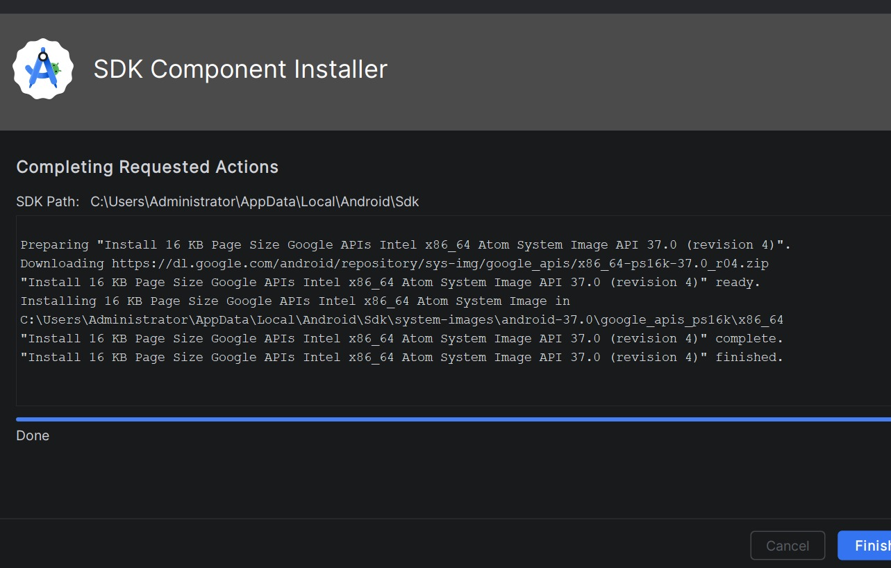

Activity 3: Flutter SDK Installation
The Flutter SDK (version 3.44.0 stable) was downloaded as a zip file and extracted to C:\flutter using PowerShell. The Flutter bin directory was then added to the Windows system PATH environment variable using an Administrator Command Prompt.

Extraction command used:
powershell -command "Expand-Archive -Path
'C:\Users\HP\Downloads\flutter_windows_3.44.0-stable.zip'
-DestinationPath 'C:\' -Force"

PATH configuration command (run as Administrator):
setx PATH "%PATH%;C:\flutter\bin" /M
SUCCESS: Specified value was saved.

Final flutter doctor output after all configurations:
Doctor summary:
[v] Flutter (Channel stable, 3.44.0, on Microsoft Windows [Version 10.0.22621.4317])
[v] Windows Version (11 Pro 64-bit, 22H2, 2009)
[v] Android toolchain - develop for Android devices (Android SDK version 36.1.0)
[v] Chrome - develop for the web
[v] Connected device (3 available)
[v] Network resources
! Doctor found issues in 1 category. (Visual Studio - not needed for Android)

Activity 4: Flutter and Dart Plugin Installation
Opened Android Studio and navigated to File > Settings > Plugins. Searched for Flutter and installed:
- Flutter plugin (by flutter.dev) — for Flutter project support
- Dart plugin — installed automatically as a Flutter dependency
Android Studio was restarted after installation. The Welcome screen now showed the New Flutter Project option, confirming successful plugin installation.

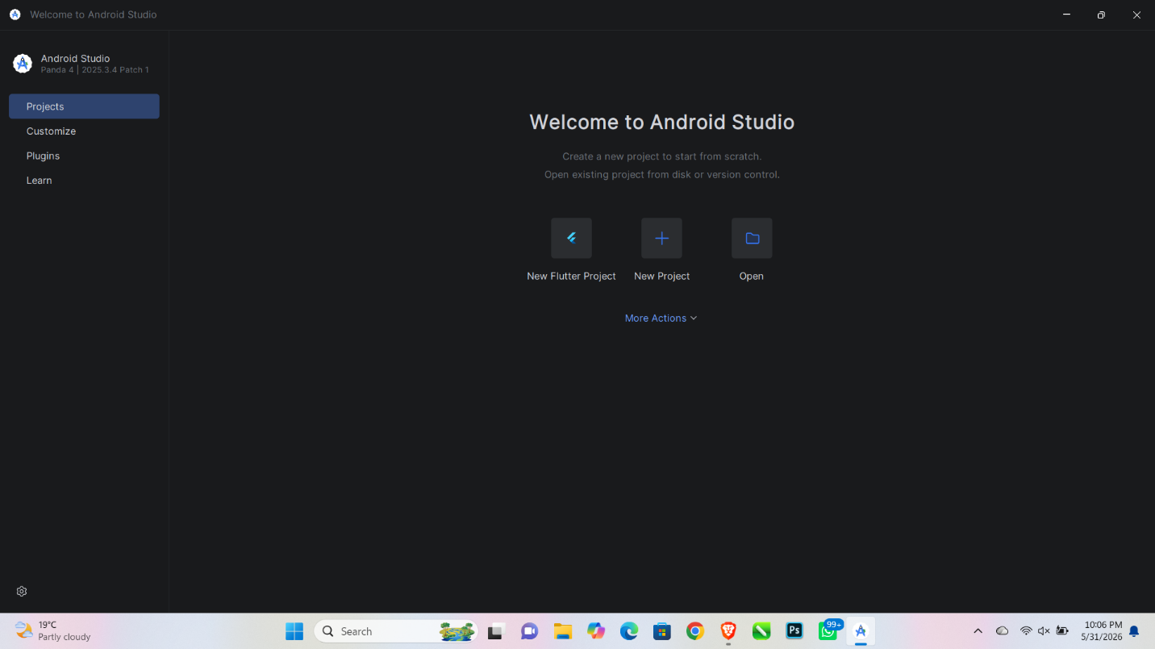

Activity 5: Android License Acceptance
Ran the android-licenses command to accept all 7 pending Android SDK package licenses. Each license was reviewed and accepted by typing y and pressing Enter.

flutter doctor --android-licenses
7 of 7 SDK package licenses not accepted.
Review licenses that have not been accepted (y/N)? y
... (accepted all 7 licenses)
All SDK package licenses accepted.

Activity 6: Real Device Connection (INFINIX X669)
Connected an INFINIX X669 Android phone running Android 12.0 to the PC via USB cable. Enabled USB Debugging by following these steps on the phone:
- Settings > About Phone > tapped Build Number 7 times
- You are now a developer! message appeared
- Settings > Developer Options > enabled USB Debugging
- Connected USB cable > tapped OK on the Allow USB Debugging popup
- Android Studio detected the device as: INFINIX Infinix X669 Android 12.0

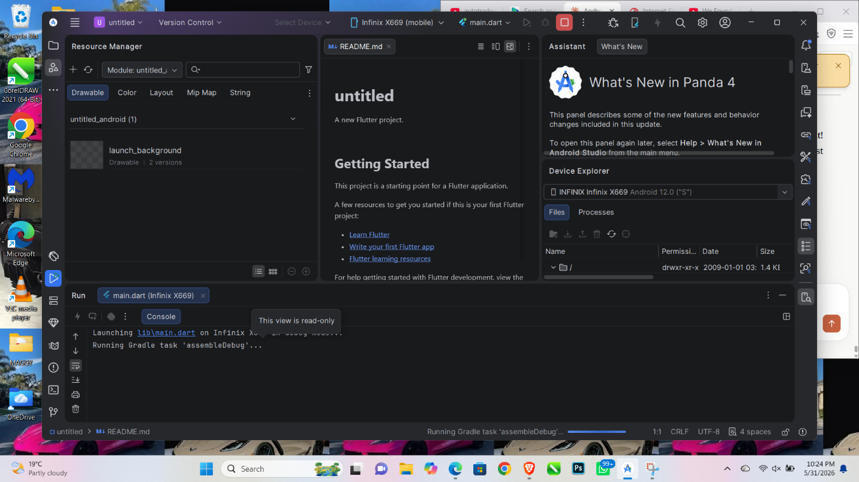

Activity 7: Creating and Running the Flutter App
Created a new Flutter project using File > New > New Flutter Project in Android Studio. Selected the INFINIX X669 as the target device and ran the app via Command Prompt.

Setting | Value
Project Name | untitled
Location | C:\Users\HP\StudioProjects\untitled
Organization | com.student
Flutter SDK Path | C:\flutter
Target Device | INFINIX X669 (Android 12.0)
Run Command | flutter run
Result | App launched successfully on device

cd C:\Users\HP\StudioProjects\untitled
flutter run
Launching lib\main.dart on Infinix X669 in debug mode...
Running Gradle task 'assembleDebug'...
Built build\app\outputs\flutter-apk\app-debug.apk (8.8s)
Flutter run key commands:
r Hot reload. R Hot restart. q Quit.

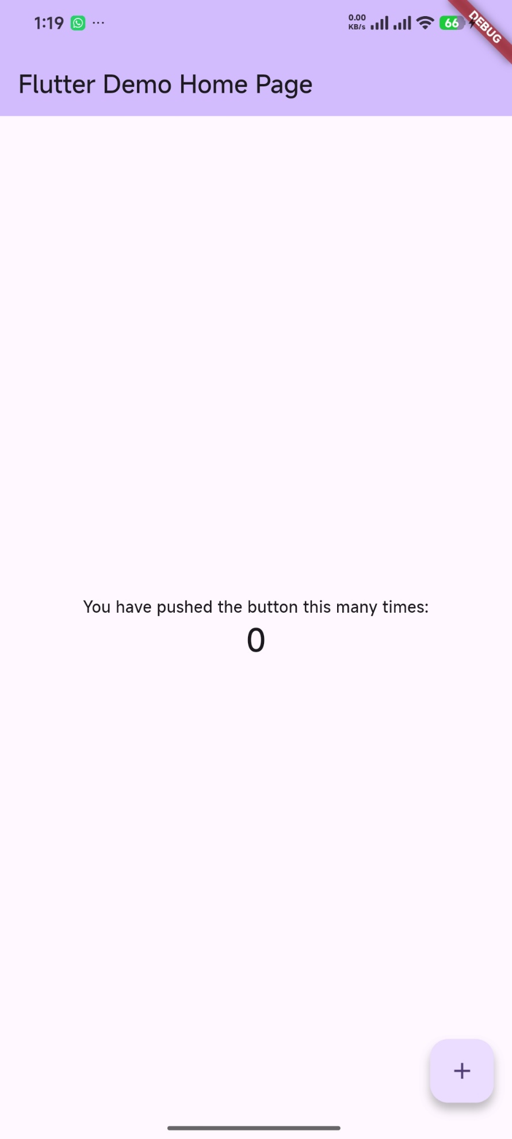

Activity 8: App Customization
Modified lib/main.dart to fulfill the Week 1 assignment requirements. Four changes were made to the default Flutter app:

# | Change Made | Before | After
1 | App Title | Flutter Demo | Hello World App
2 | Page Title | Flutter Demo Home Page | My First Flutter App
3 | Background Color | Purple (inversePrimary) | Light Blue (Colors.lightBlue[100])
4 | Counter Font Size | Default headlineMedium | 48px Bold Dark Blue
5 | New Button Added | None | Orange ElevatedButton — Click Me!

The complete customized main.dart file:
import 'package:flutter/material.dart';

void main() { runApp(const MyApp()); }

class MyApp extends StatelessWidget {
const MyApp({super.key});
@override
Widget build(BuildContext context) {
return MaterialApp(
title: 'Hello World App',
theme: ThemeData(
colorScheme: ColorScheme.fromSeed(seedColor: Colors.deepPurple),
),
home: const MyHomePage(title: 'My First Flutter App'),
);
}
}

class _MyHomePageState extends State<MyHomePage> {
int _counter = 0;
void _incrementCounter() { setState(() { _counter++; }); }

@override
Widget build(BuildContext context) {
return Scaffold(
appBar: AppBar(
backgroundColor: Colors.lightBlue,
title: Text(widget.title, style: TextStyle(color: Colors.white)),
),
backgroundColor: Colors.lightBlue[100],
body: Center(
child: Column(
mainAxisAlignment: MainAxisAlignment.center,
children: [
const Text('You have pushed the button this many times:',
style: TextStyle(fontSize: 18)),
Text('\$_counter',
style: TextStyle(fontSize: 48, fontWeight: FontWeight.bold,
color: Colors.lightBlue[900])),
],
),
),
bottomNavigationBar: Padding(
padding: EdgeInsets.all(16.0),
child: ElevatedButton(
onPressed: () {},
style: ElevatedButton.styleFrom(
backgroundColor: Colors.orange,
padding: EdgeInsets.symmetric(vertical: 16)),
child: Text('Click Me!',
style: TextStyle(fontSize: 20, color: Colors.white)),
),
),
floatingActionButton: FloatingActionButton(
onPressed: _incrementCounter,
child: const Icon(Icons.add),
),
);
}
}

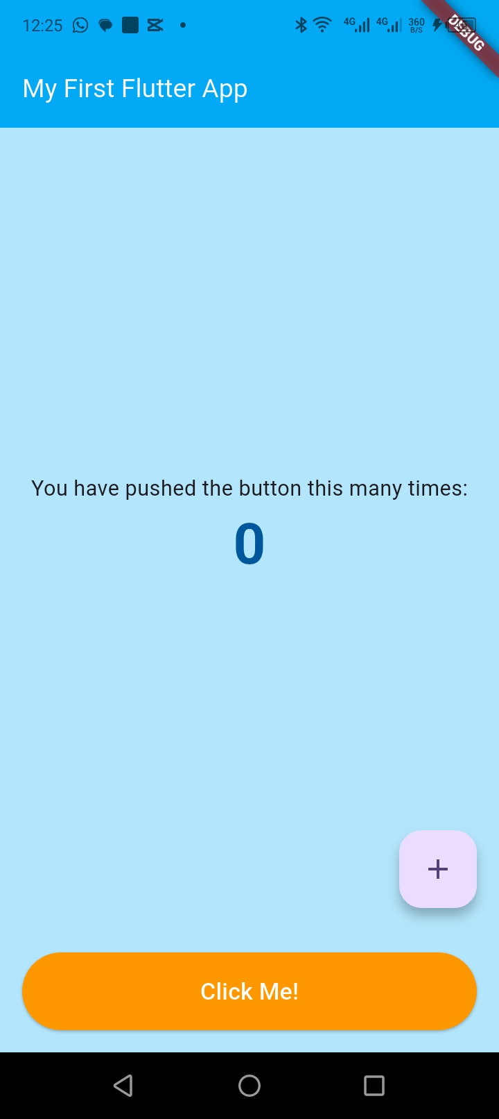

3. CHALLENGES FACED AND SOLUTIONS IMPLEMENTED

Note: Screenshots of the error messages were not captured at the time they occurred. The errors below are documented from memory and the actual terminal output that was recorded during the troubleshooting process.

Challenge 1: Flutter Not Recognized in Command Prompt
ERROR ENCOUNTERED: 'flutter' is not recognized
After the Flutter SDK zip was extracted to C:\flutter, running flutter doctor in Command Prompt returned an error. The system could not find Flutter because the bin directory had not been added to the Windows PATH environment variable.
C:\Users\HP>flutter doctor 'flutter' is not recognized as an internal or external command, operable program or batch file.Root Cause
The Flutter SDK was inside C:\flutter\bin but Windows did not know to look there when a command is typed. The PATH variable tells Windows where to search for executable programs.

SOLUTION: Opened Command Prompt as Administrator and ran: setx PATH "%PATH%;C:\flutter\bin" /M — this permanently added C:\flutter\bin to the system PATH. After closing and reopening Command Prompt, flutter doctor worked correctly.

Challenge 2: Android Emulator Hypervisor Driver (AEHD) Failed
ERROR ENCOUNTERED: AEHD Service Could Not Start
When attempting to install the Android Emulator Hypervisor Driver from Android Studio's SDK Manager to enable the Android emulator, the installer ran but the Windows service failed to start.
Running Android Emulator hypervisor driver installer [SC] ControlService FAILED 1062: The service has not been started. [SC] DeleteService SUCCESS [SC] StartService FAILED with error 4294967201. Done

Root Cause
The AEHD driver requires hardware virtualization to be enabled at the BIOS level. On this machine, virtualization was either disabled or the Windows Hypervisor Platform feature was not active, preventing the AEHD service from starting.

SOLUTION: Instead of spending more time fixing the emulator, the decision was made to use the INFINIX X669 physical Android phone as the testing device. This is actually the preferred approach for Kenyan developers as it tests on real hardware that reflects actual user devices.

Challenge 3: Gradle Build Failed — DNS / Network Error
ERROR ENCOUNTERED: Could not reach storage.googleapis.com
On the first attempt to run the Flutter app, Gradle needed to download the Flutter engine binaries from Google's servers. After 26 minutes of waiting, the build failed because the PC could not resolve Google's storage domain.
> Could not GET 'https://storage.googleapis.com/download.flutter.io/...' > No such host is known (storage.googleapis.com) BUILD FAILED in 26m Error: Gradle task assembleDebug failed with exit code 1

Root Cause
The default DNS server provided by the ISP (Safaricom/local router) was failing to resolve Google's domain names. This is a common issue in Kenya where some ISP DNS servers have poor reliability for international domains.

SOLUTION: Changed the DNS settings on the network adapter to Google's public DNS: Preferred DNS 8.8.8.8 and Alternate DNS 8.8.4.4. Tested with ping storage.googleapis.com — received 4/4 replies with 12ms average. Ran flutter clean then flutter run and the build succeeded.

Ping test result after DNS change:
C:\Users\HP>ping storage.googleapis.com
Pinging storage.googleapis.com [172.217.170.187] with 32 bytes of data:
Reply from 172.217.170.187: bytes=32 time=11ms TTL=114
Reply from 172.217.170.187: bytes=32 time=14ms TTL=114
Reply from 172.217.170.187: bytes=32 time=15ms TTL=114
Reply from 172.217.170.187: bytes=32 time=11ms TTL=114
Packets: Sent=4, Received=4, Lost=0 (0% loss)

Challenge 4: setx Command Access Denied
ERROR ENCOUNTERED: Registry Access Denied
When attempting to add Flutter to the system PATH using setx, the command failed because it was run from a normal (non-administrator) Command Prompt window.
C:\Users\HP>setx PATH "%PATH%;C:\flutter\bin" /M ERROR: Access to the registry path is denied.

Root Cause
The /M flag in setx modifies the SYSTEM environment variables, which requires administrator privileges. Running from a regular Command Prompt does not have permission to write to the system registry.

SOLUTION: Closed the regular Command Prompt. Searched for cmd in the Start menu, right-clicked Command Prompt, and selected Run as administrator. Ran the setx command again and received: SUCCESS: Specified value was saved.

4. TESTING EVIDENCE

Test Item | Expected Result | Actual Result | Status
java -version command | Shows Java version | openjdk version 25.0.3 | PASS
flutter doctor | All Android items green | Flutter + Android toolchain green | PASS
Device detection | Phone appears in Android Studio | INFINIX X669 detected | PASS
App launch on device | App opens on phone | Flutter Demo app opened | PASS
Title change | Shows My First Flutter App | Title updated correctly | PASS
Background color | Light blue background | Light blue applied | PASS
Font size change | Counter shows 48px bold | Large bold counter visible | PASS
Button added | Orange button at bottom | Click Me button visible | PASS

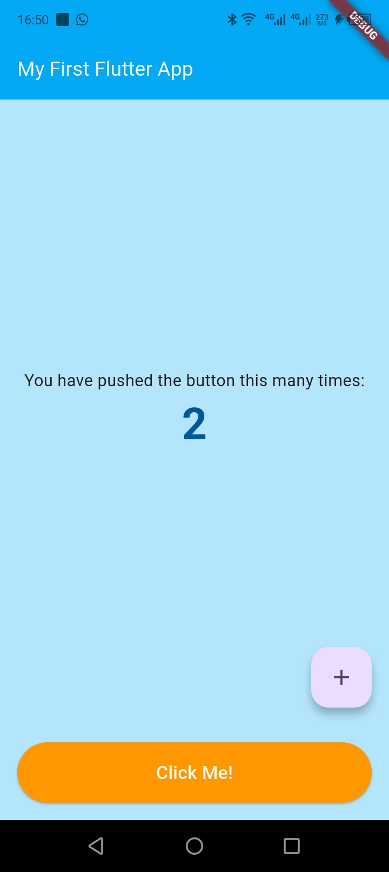

5. REFLECTIONS AND LESSONS LEARNT

Week 1 was a challenging but highly educational experience. The setup process revealed several real-world problems that developers in Kenya commonly face — network restrictions, driver compatibility issues, and environment configuration. Overcoming these challenges built strong troubleshooting skills that will be useful throughout the course.

Key Lessons Learnt
- Environment setup is often the hardest part of mobile development — getting all tools to work together correctly takes patience and systematic troubleshooting
- The Windows PATH variable is fundamental — if it is not configured correctly, no Flutter command will work regardless of what else is installed
- DNS settings directly affect a developer's ability to download build dependencies — switching to Google DNS (8.8.8.8) solved a major blocker
- A real physical device is more practical than an emulator for developers in Kenya — it tests on actual hardware and avoids virtualization driver issues
- The flutter clean command should be the first step when any build fails unexpectedly — it removes corrupted cache files
- Hot reload (Ctrl+S) is one of Flutter's most powerful features — it updates the running app in under 1 second without restarting
- Reading error messages carefully is essential — each error in this session pointed directly to the solution once read carefully

Current Understanding of Flutter Code
At the end of Week 1, my understanding of Flutter and Dart is partial but improving. What I currently understand:
- void main() is the entry point — every Dart program starts here
- runApp() launches the Flutter app and takes a widget as its argument
- StatelessWidget is used for screens that do not change
- StatefulWidget is used for screens with interactive elements like counters
- Scaffold provides the basic app structure: AppBar (top bar), body (main content), and bottomNavigationBar
- Column and Center are layout widgets that position other widgets on screen
- setState() tells Flutter to redraw the screen when data changes
- Colors.lightBlue and Colors.orange are built-in Flutter color constants

What I still need to learn:
- How to create custom widgets from scratch
- How widget nesting works in complex layouts
- How to pass data between different screens
- How to connect the app to a database or API

What I Would Do Differently
- Take screenshots of every error immediately when it occurs — this makes documentation much easier later
- Change DNS settings before attempting the first Gradle build to avoid the 26-minute failed build
- Run Command Prompt as Administrator from the very beginning for all environment setup steps
- Keep a notepad open during setup to write down every command used and its result

6. PLAN FOR WEEK 2

Week 2 focuses on Programming Languages and Frameworks. The following activities are planned:
- Practice Dart syntax: variables, functions, loops, and classes using small test programs
- Build a Mini Student Management App with login screen, registration, and local data storage
- Learn SharedPreferences package for saving student records on the device without internet
- Implement multi-screen navigation using Flutter's Navigator
- Begin planning the SpareDash app structure — screens, data models, and navigation flow

SpareDash Connection: In Week 2, work will begin on the SpareDash Login Screen (phone number + OTP) and the Part Search Screen with basic car model filtering. The student management app will serve as practice for the same patterns used in SpareDash.

BIT4107 Mobile Application Development | Week 1 Project Logbook | June 2026

